**Organizational Behavior**

**Assignment no 1**

**CASE INCIDENT**

**“CRAFTING A BETTER JOB”**

**Marks 05**

**The case application is at Page no 91 in the book “Organizational Behavior by Robbins and Judge”.**

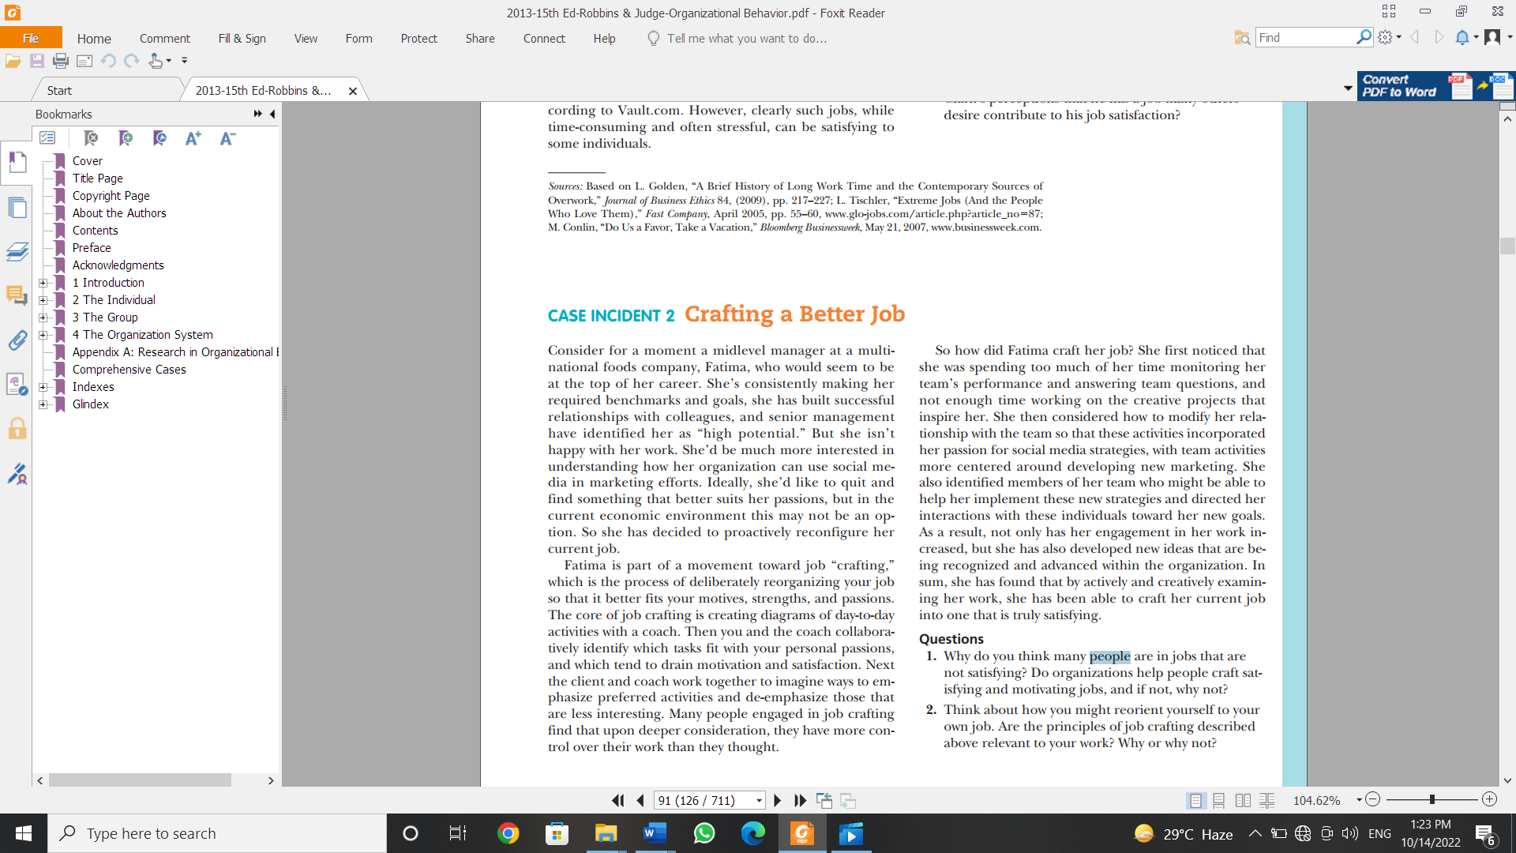

1. **Memorize the Chapter “Attitudes and Job Satisfaction” and attempt the case.**

**Requirements for the Assignment**

* Read the Case Incident thoroughly and answer the following questions.
* As these questions requires your take on the situation. You answer must be in your own words.
* Assignments plagiarized or copied will be canceled and marked zero. Plagiarism could be checked through Turnitin, if any assignment found suspicious. In case of copied from students both or all copied assignments will be canceled and marked zero

Note: Academic dishonesty is unacceptable and unforgiveable. Doing so will cost the full marks of the assignment.

**Assignment Date: 14-10-2022**

**Submission Date: 18-10-2022**

**-----------End of Document-------------**